Filtering and Sorting
EmpID | EmpName | Department | City | Salary | HireDate
101 | Rahul Mehta | Sales | Delhi | 55000 | 2020-04-12
102 | Priya Sharma | HR | Mumbai | 62000 | 2019-09-25
103 | Aman Singh | IT | Bengaluru | 72000 | 2021-03-10
104 | Neha Patel | Sales | Delhi | 48000 | 2022-01-14
105 | Karan Joshi | Marketing | Pune | 45000 | 2018-07-22
106 | Divya Nair | IT | Chennai | 81000 | 2019-12-11
107 | Raj Kumar | HR | Delhi | 60000 | 2020-05-28
108 | Simran Kaur | Finance | Mumbai | 58000 | 2021-08-03
109 | Arjun Reddy | IT | Hyderabad | 70000 | 2022-02-18
110 | Anjali Das | Sales | Kolkata | 51000 | 2023-01-15

Question-1 Show employees working in either the ‘IT’ or ‘HR’ departments.
Answer-- 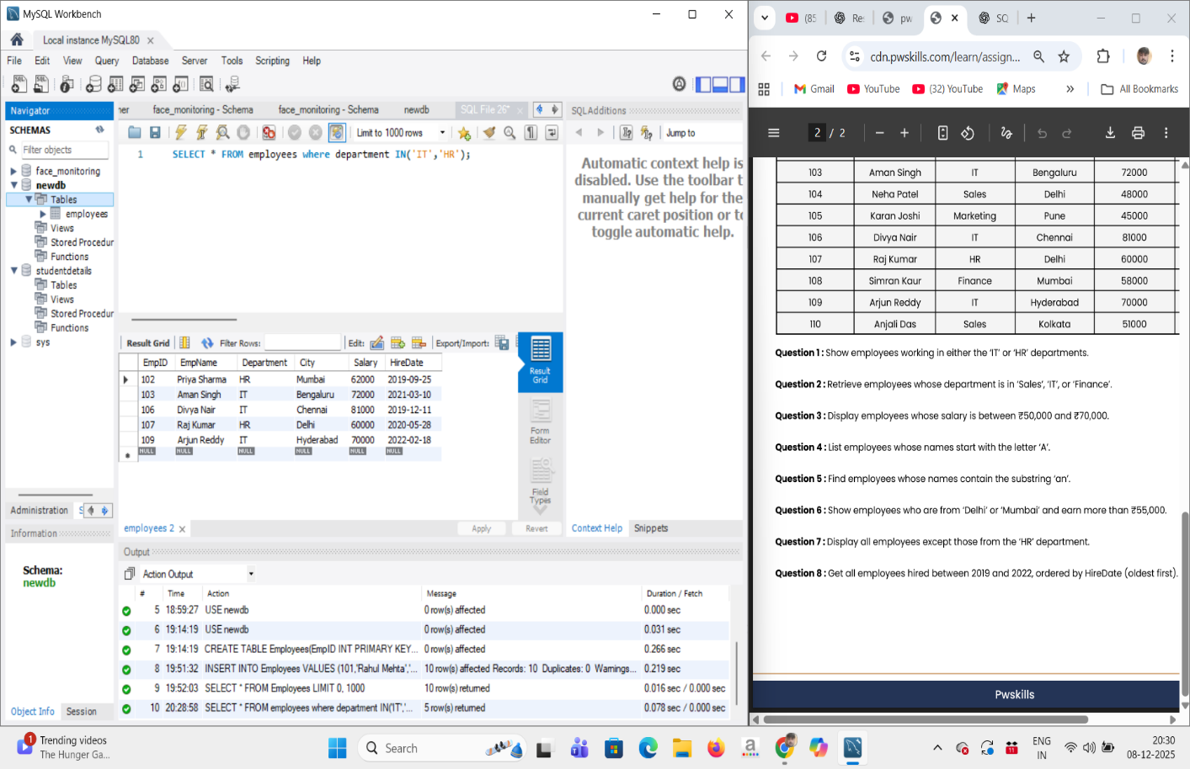

Question-2 Retrieve employees whose department is in ‘Sales’, ‘IT’, or ‘Finance’.
Answer-- 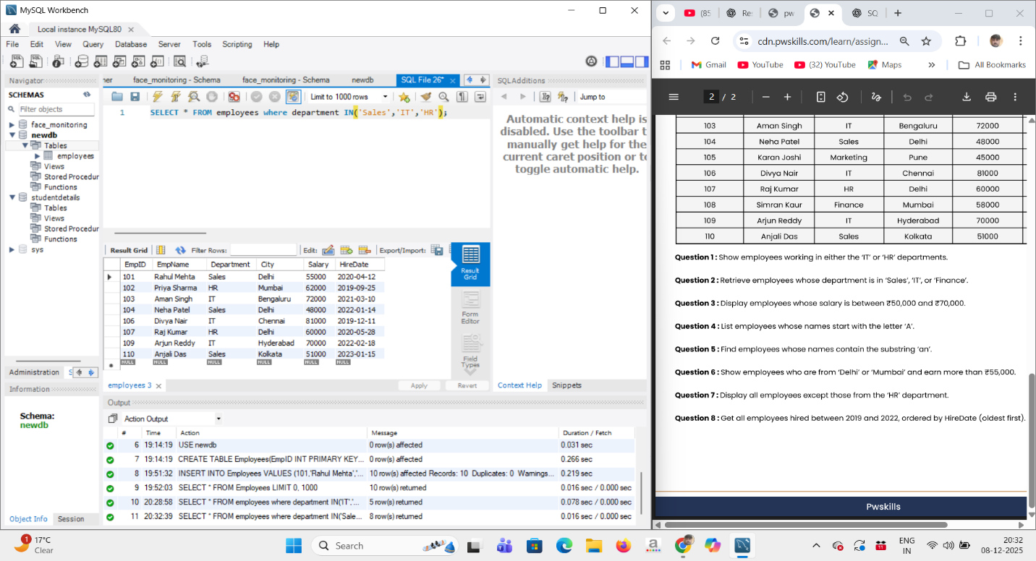
Question-3 Display employees whose salary is between ₹50,000 and ₹70,000.
Answer-- 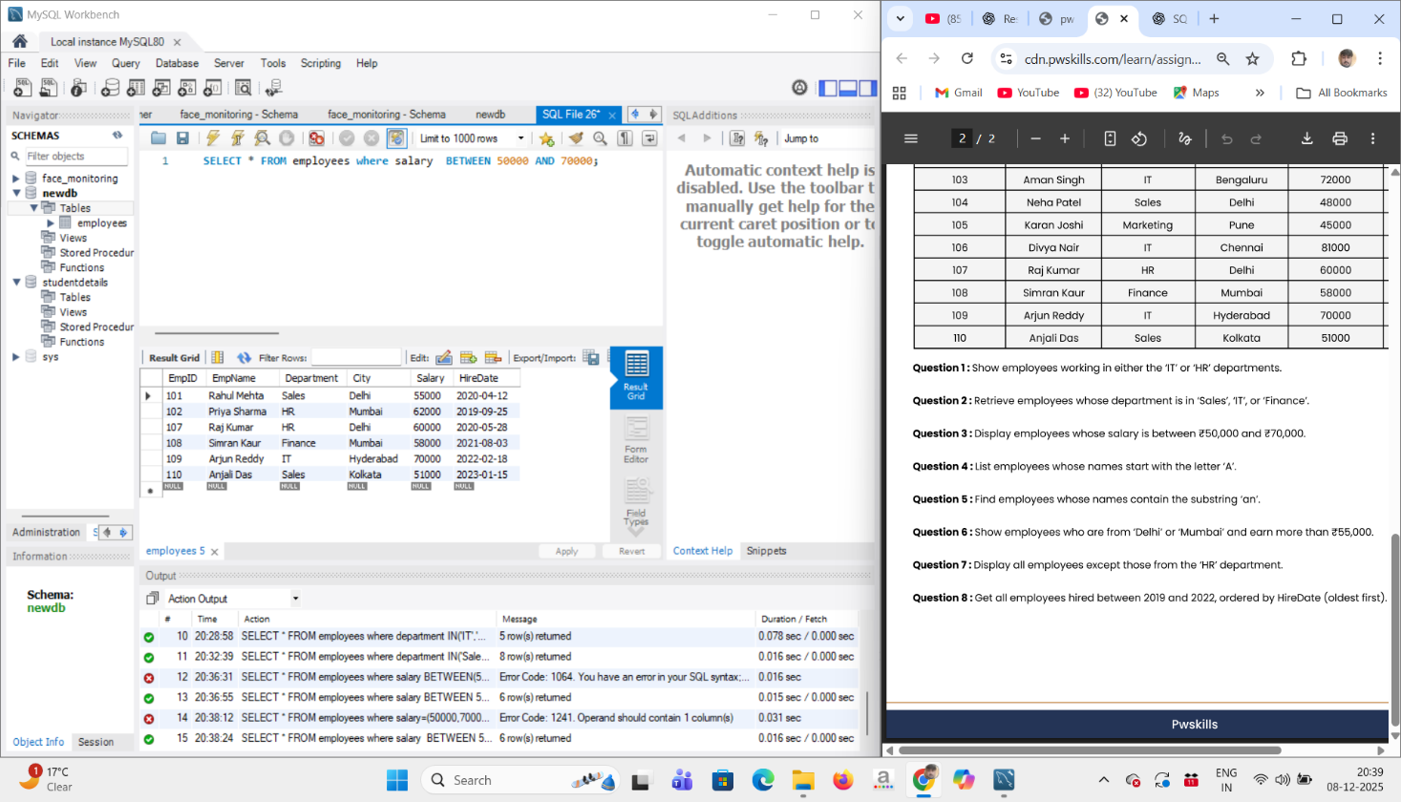

Question-4 List employees whose names start with the letter ‘A’.
Answer-- 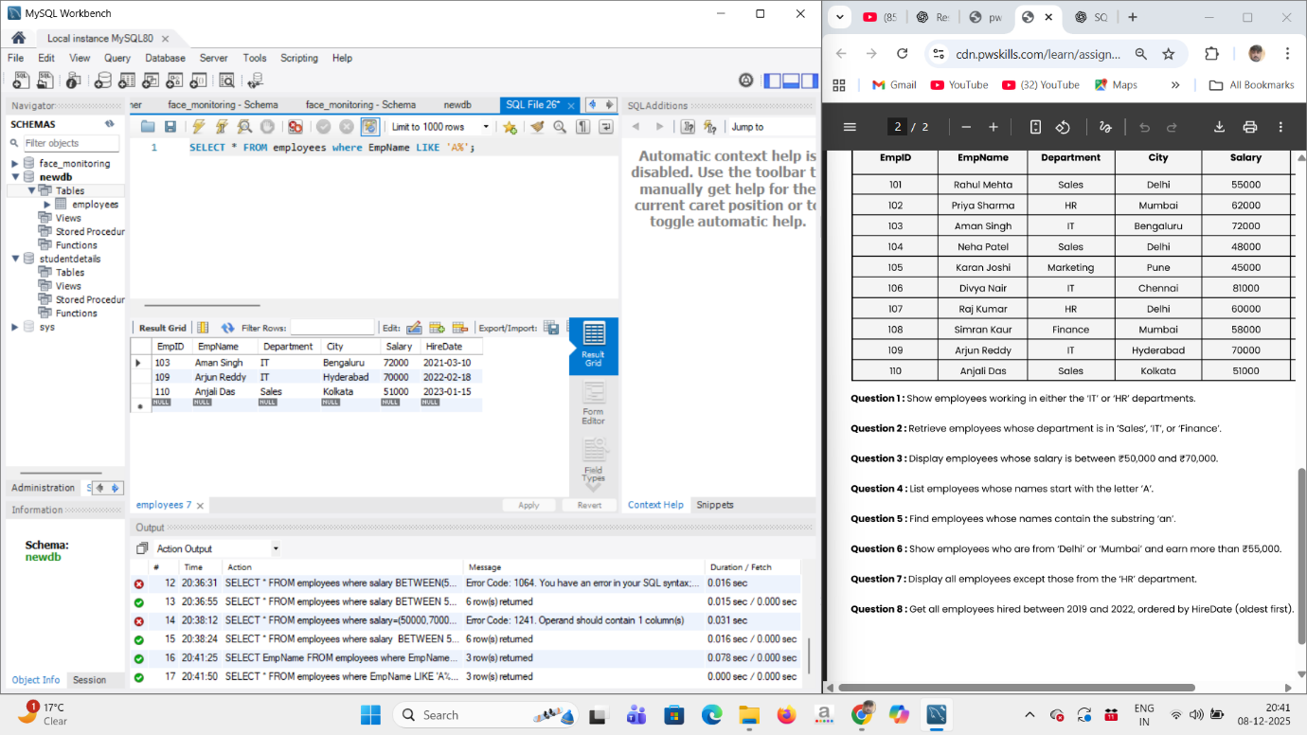

Question-5 Find employees whose names contain the substring ‘an’.
Answer-- 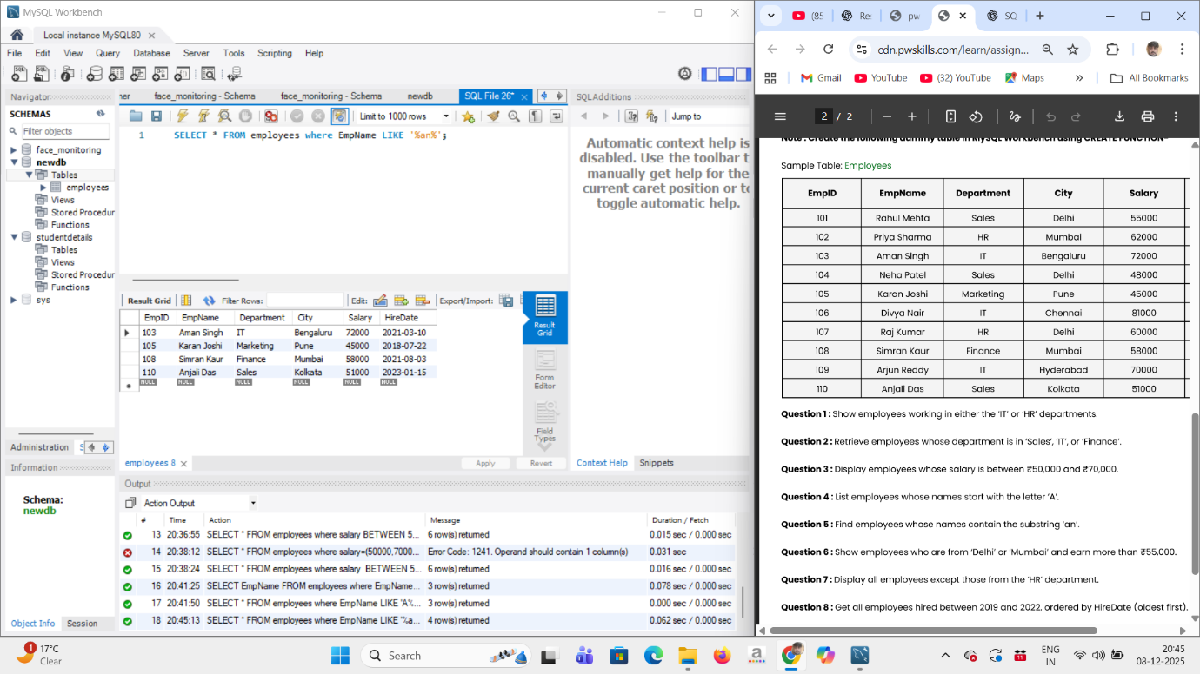

Question-6 Show employees who are from ‘Delhi’ or ‘Mumbai’ and earn more than ₹55,000.
Answer-- 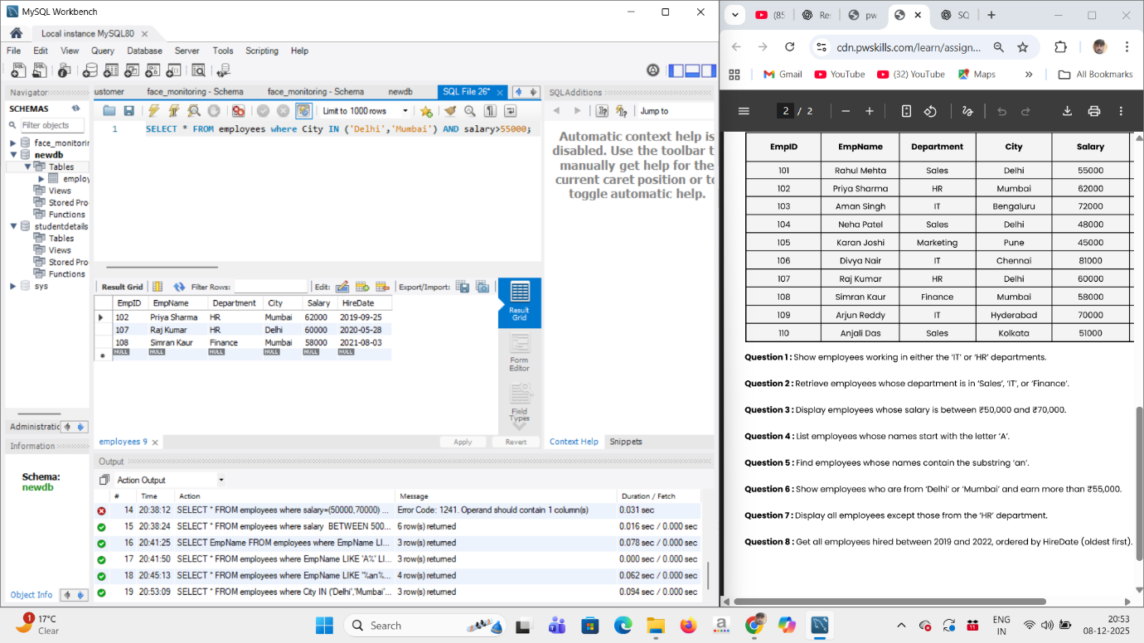

Question-7 Display all employees except those from the ‘HR’ department.
Answer-- 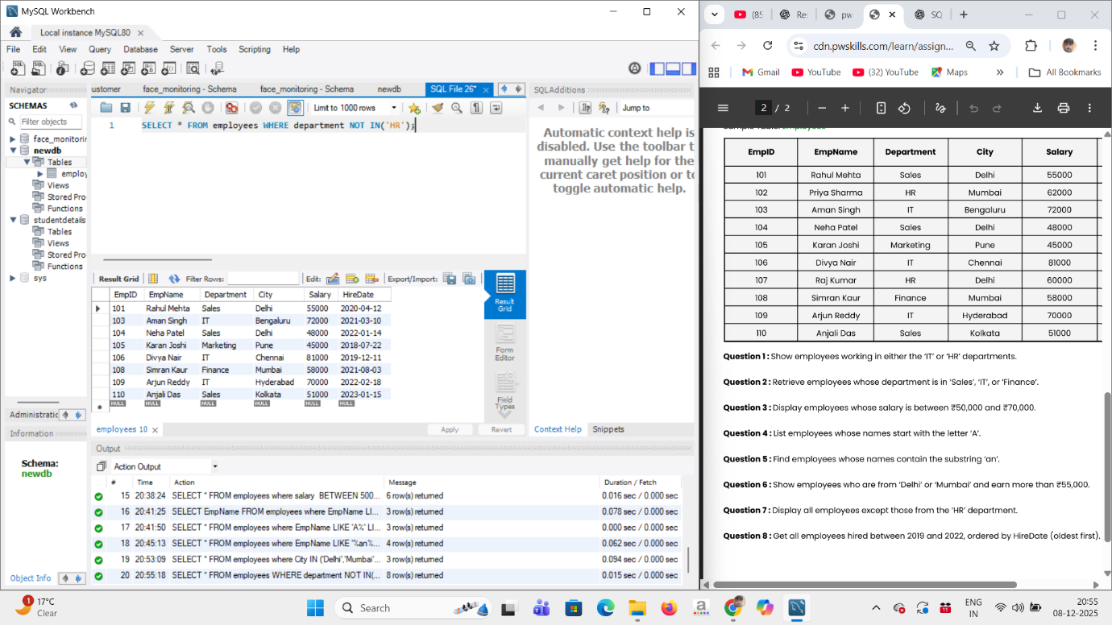

Question-8 Get all employees hired between 2019 and 2022, ordered by HireDate (oldest first).
Answer-- 